Subject: **Partner Portal First Time Use and New User Registration**

|  |  |  |  |
| --- | --- | --- | --- |
| Product: | Partner Portal | Date: | August 19, 2016 |
| Author: | Kozak, Jay | Version: | V3.0 |
| Keywords: | Partner Portal; IPlus, Login |  |  |

Status: **Active**

**Document Overview:**

* Section One below explains how to login to the Partner Portal for first time use.
* Section Two below explains the process of registering for a new Partner Portal account, in the event where you cannot remember your Partner Portal email address.

**Section One: Resetting Your Password for First Time Use**

1. Launch the new [Partner Portal](http://www.ncc-ops.com/partnerportal/) site
   1. If you have an existing Partner Portal account, you must change your password upon first login to the updated version of the Portal by leaving the user ID field blank and clicking on the Lost Password hyperlink.

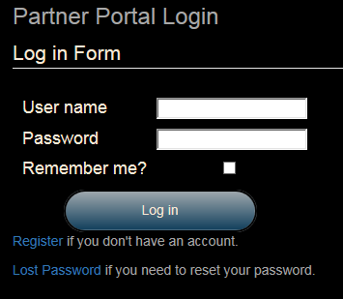

* 1. Enter the email address provided when you registered for the legacy version of the Partner Portal. If you do not remember what email address is on file, you must Register for a new Partner Portal account. See instructions below in **Section Two: Partner Portal Registration Steps.**

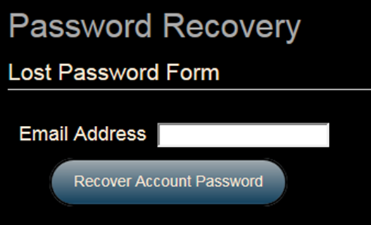

* 1. A password reset link will be sent to the specified email address with a subject of "Reset your Partner Portal Password". If you do not find the email, please check your spam and junk email folders before contacting the administrators.
  2. Enter and confirm your new Partner Portal password and click on the Reset Password Button.

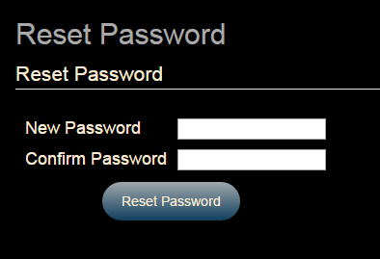

**Section Two: Partner Portal Registration Steps**

1. Click on the blue Register link at the top right hand corner of the screen or under the Log in button

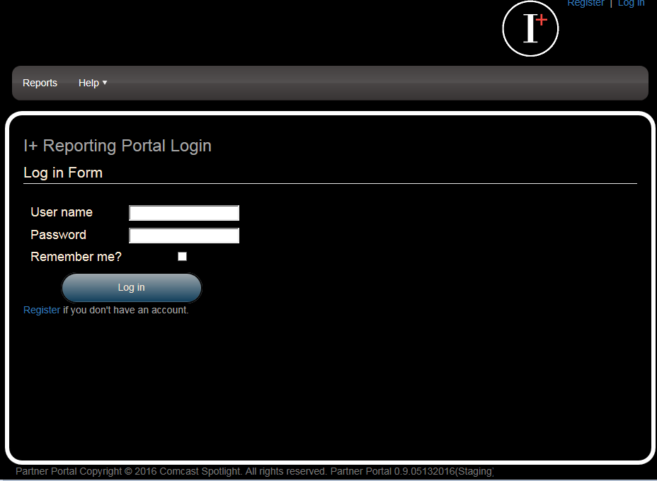

* 1. Fill out the registration form with your information. Click the Register Button when you are ready to submit the form for processing.

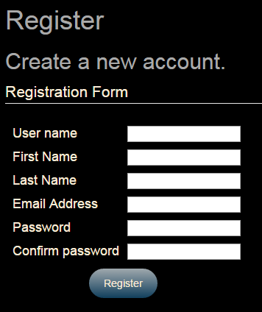

**Note: It is requested that when registering for your Partner Portal account to you use your company email address. This will help ensure that you are given the proper Partner Portal access rights when the request is received.**

* 1. You will not have access to any of the reporting tools until your request has been processed and your roles have been assigned. Please allow 24 hours for your request to be processed. A notification will be sent to your registered email address once the request has been successfully completed.