Subject: **Partner Portal Report Types Overview**

|  |  |  |  |
| --- | --- | --- | --- |
| Product: | Partner Portal | Date: | August 19, 2016 |
| Author: | Bastidas, Dustin | Version: | v1.0 |
| Keywords: | Partner Portal; IPlus |  |  |

Status: **Active**

**Document Overview:**This document provides a brief overview of the various reports in which the Partner Reporting Portal provides to its user base.

1. ***DTV Match***

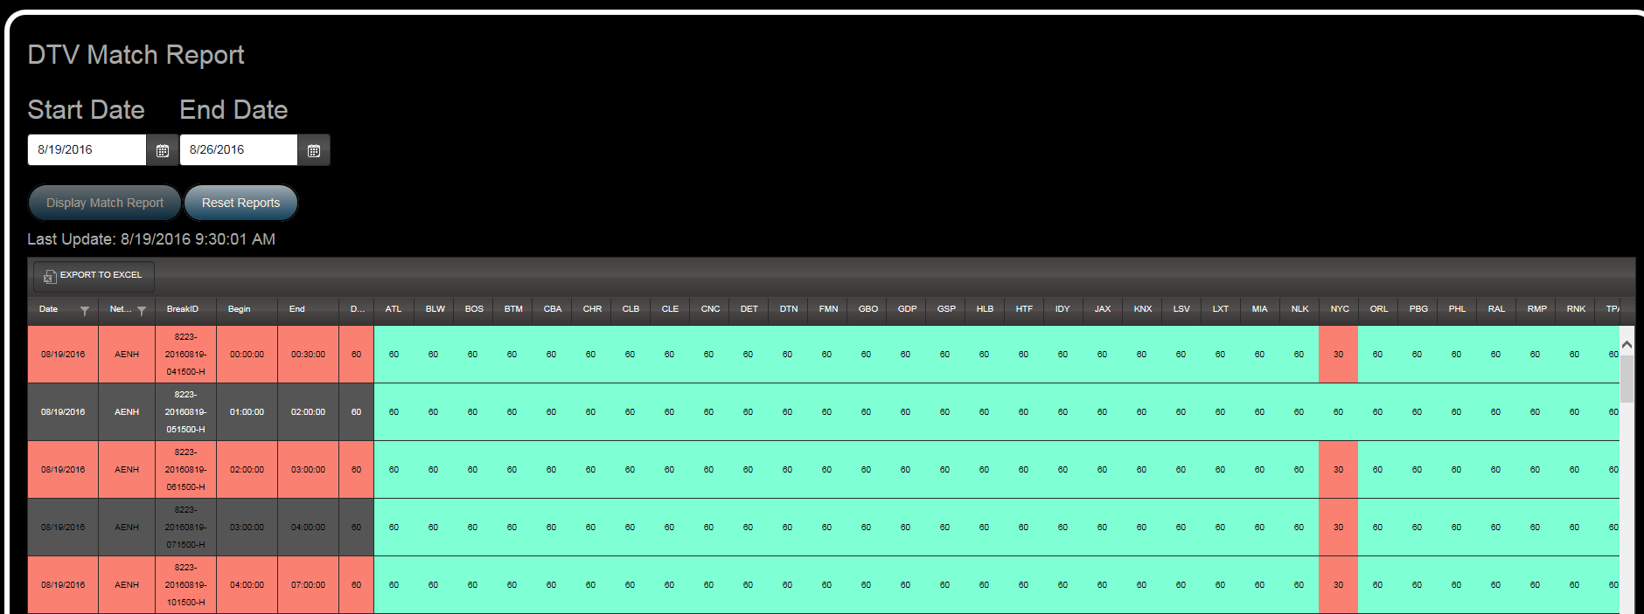

* 1. The DTV Match Report provides an overview of schedules that are currently loaded on the DirecTV ZTA platform in relation to available inventory. In this report, Platform Participating Partners will see the Inventory Allocation BreakID (UTC), Inventory Allocation Duration, Inventory Allocation Start/End Times (normalized to ET), as well as the duration of their scheduled breaks against the available inventory for any given network. Partners can utilize this report to identify the inventory that is available to them as well as where they are not filling all available inventory.

1. ***Dish Match***

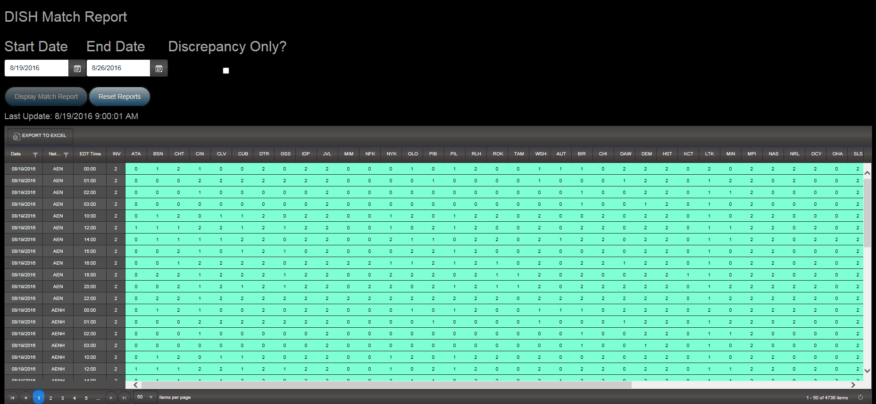

1. The Dish Match Report provides an overview of schedules that are currently loaded on the Dish ZTA platform in relation to available inventory. In this report, platform participating partners will see the count of spot positions that are available per Inventory Allocation, as well as the Inventory Allocation Start Time (normalized to ET). They can also see the corresponding count of their scheduled spot positions relative to the available inventory for any given network. Partners can utilize this report to identify the inventory that is available to them, where they are not filling available inventory, as well as where they are attempting to schedule breaks in which inventory is not available.
2. ***DTV Unallocated Breaks***

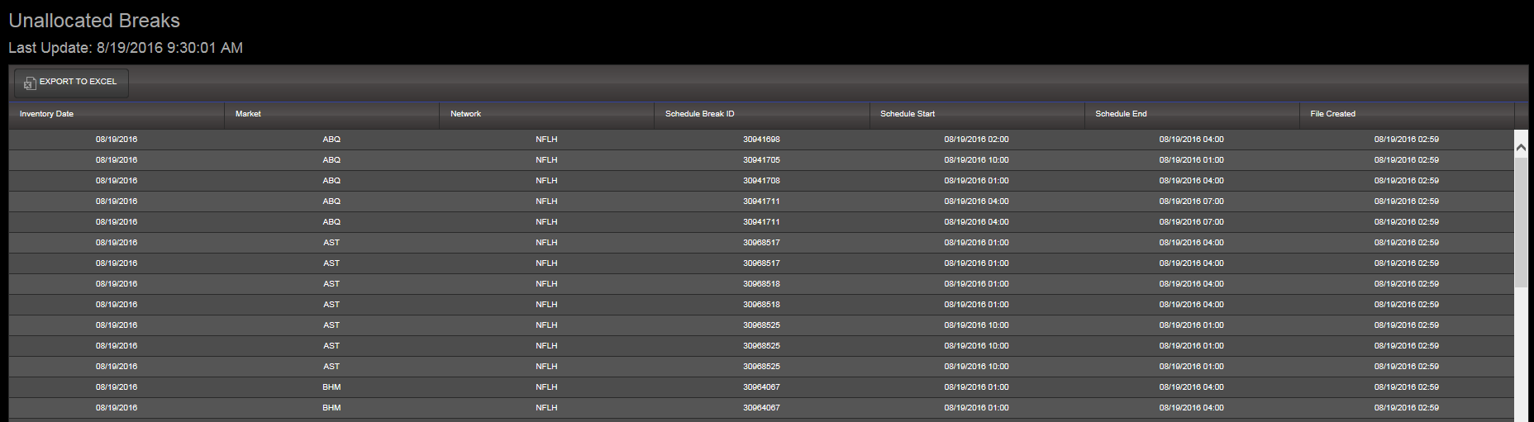

* 1. The DTV Unallocated Breaks reports provides an overview of “orphaned” breaks based on schedules received for the DirecTV ZTA platform. These are breaks in which participating partners are attempting to schedule that do not fit into any available inventory. Breaks present on this report will not return a valid verification disposition. Partners can use this report to identify and clean up their schedules of any breaks that do not fit inventory available inventory.

1. ***DTV/Dish Performance***
   1. ***Run Rate by Market***

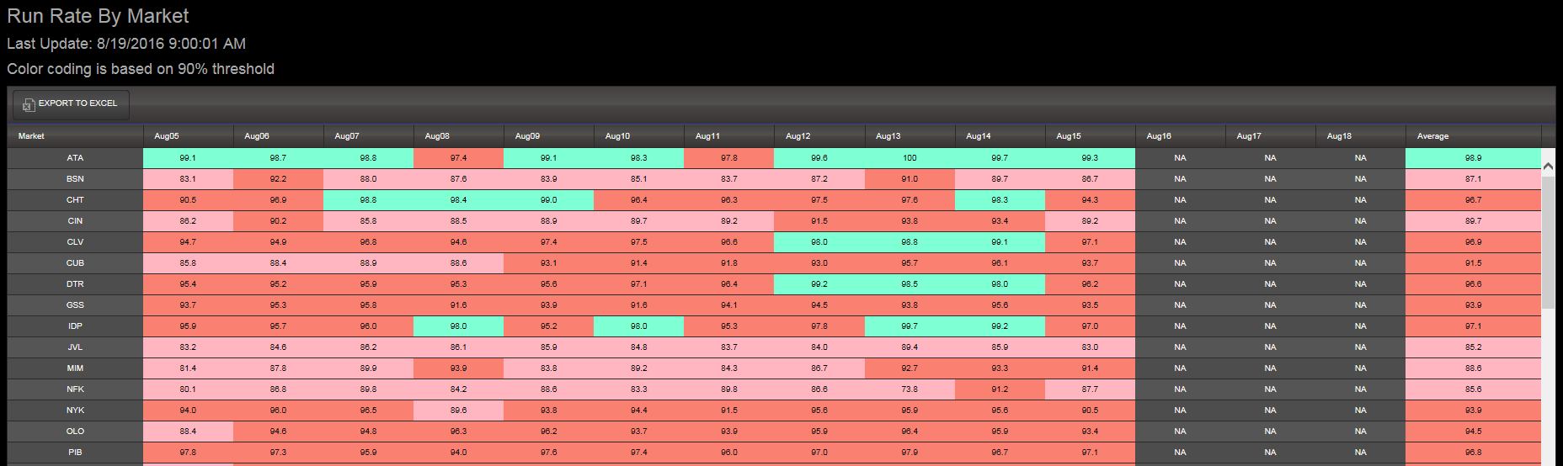

* + 1. The Run Rate by Market report provides the current Run Rate % (Successes/Total LOIs) for platform markets for all available verification dates.
  1. ***Run Rate by Network***

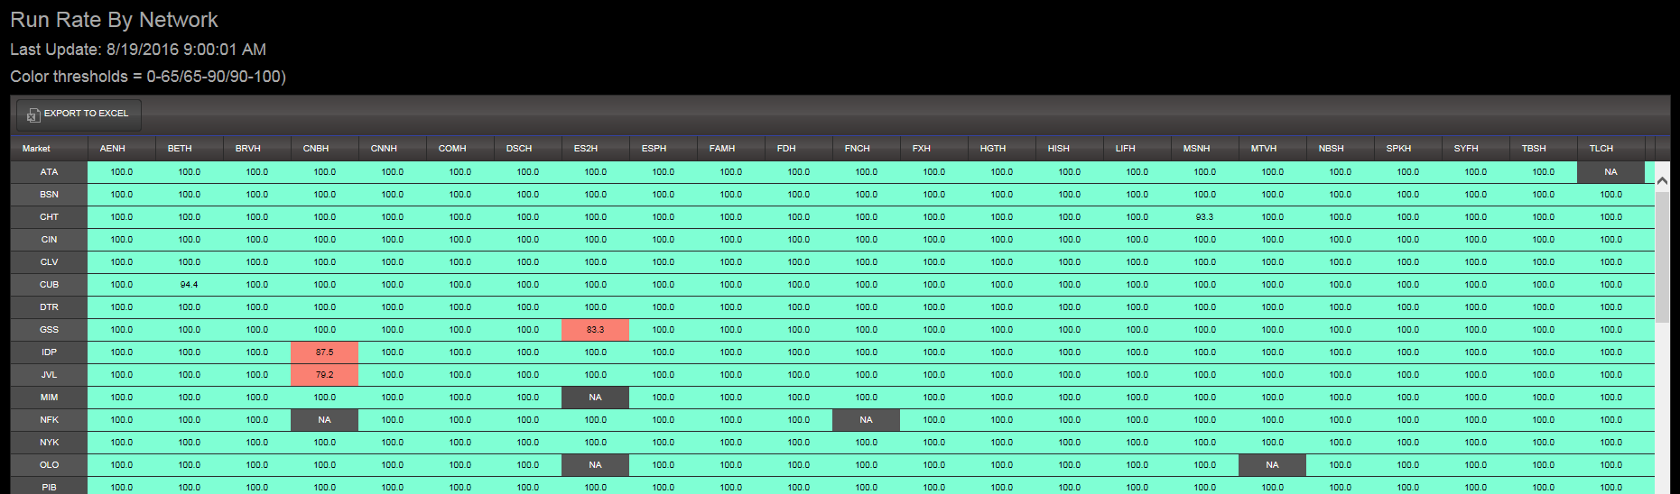

* + 1. The Run Rate by Network report provides the current Run Rate % (Successes/Total LOIs) by network for platform markets for all available verification dates.
  1. ***Performance Review***

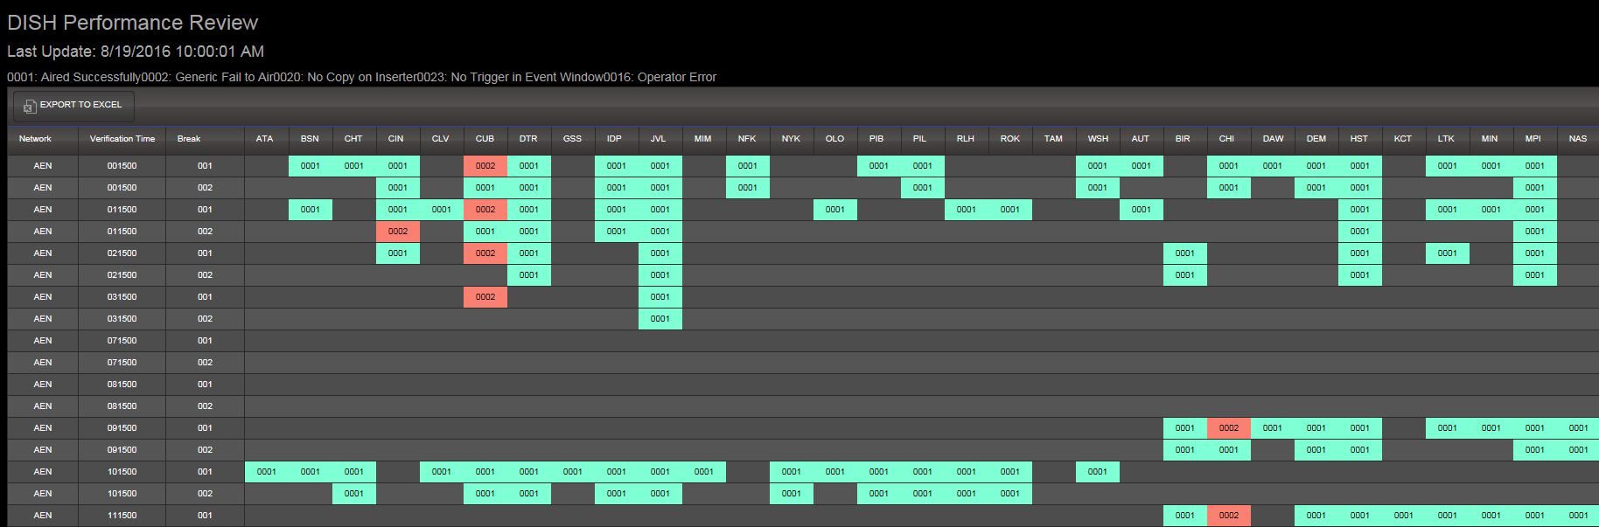

* + 1. The Performance Review report provides a complete market picture of the dispositions received for each scheduled line of insertion for all available verification dates. This should be representative of the verification files that are delivered back to the platform participating partners.